Lab Exercise 2
Chapter 2 Elementary Programming Chapter 3 Control Structures

INSTRUCTIONS TO THE STUDENTS
- This exercise must be done individually.
- Any form of plagiarism is NOT ALLOWED. Students who copied other students' assignments will get ZERO marks (both parties, students who copied, and students who shared their work).
- Please insert your name and matric number as a comment in your solution.

SUBMISSION PROCEDURE
- Please submit this exercise no later than November 23, 2023, Thursday (11.59 PM MYT).
- Only one file is required for the submission (the file with the extension .pdf).
- Submit it via the UTM's e-learning system (https://elearning.utm.my/23241/).

WRITE A C++ PROGRAM based on the tasks below:
- Set the values:
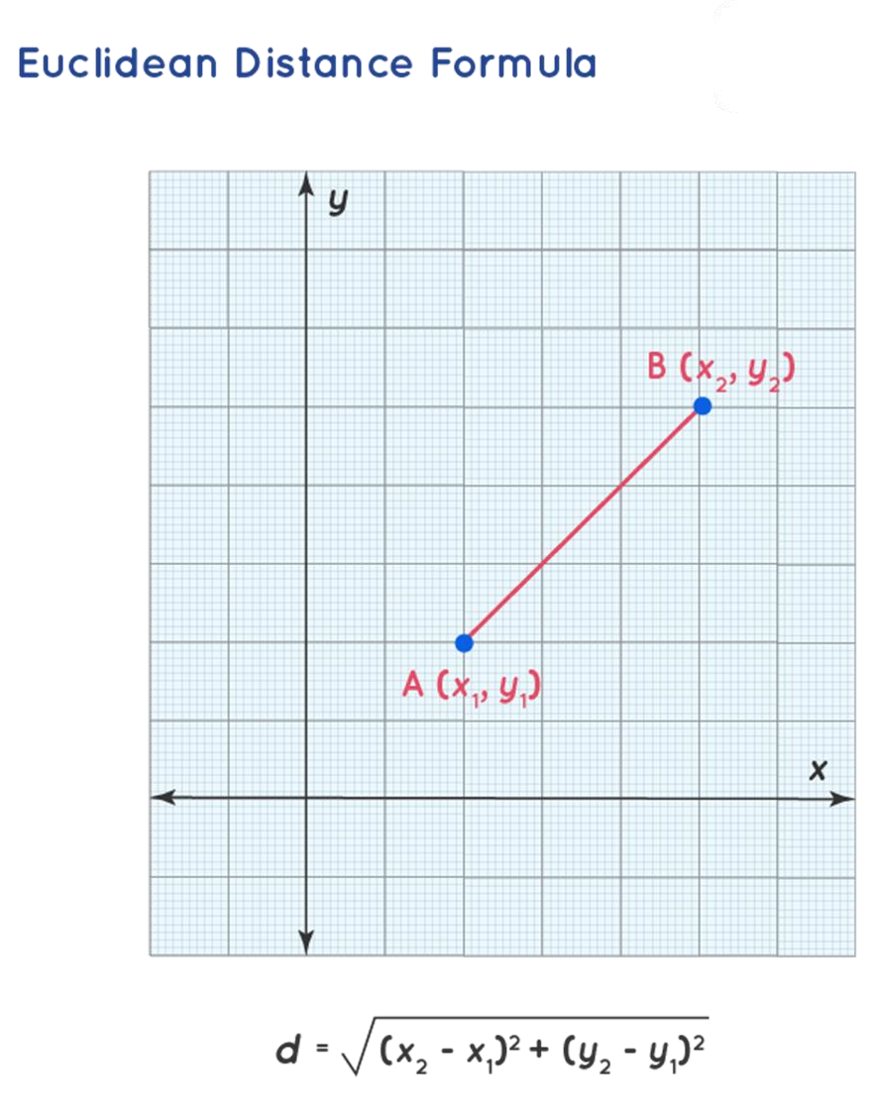
x1 = 1; y1 = 3; x2 = 2; y2 = 6; x3 = 5; y3 = 4;
- Find the distance between every pair of points A(1, 3), B(2, 6), and C(5, 4) using Euclidean Distance Formula.
- The output of the program:
A(1, 3), B(2, 6), and C(5, 4)
x y
A 1 3
B 2 6
C 5 4
AB =
AC =
BC =
//GUI KAH SIN A23CS0080

#include<iostream>
#include<cstring>
#include<iomanip>
#include<cmath>
using namespace std;

double distance(int ,int ,int ,int );//Function prototype
void display();

double distance(int a,int b, int c, int d)//Function Header
{
return sqrt(pow((b-a),2)+pow((d-c),2));//Calculate Euclidean Distance
}

void display()//Function Header No Return
{
char output1[20]= "A(1,3), B(2,6) and ";//Print Points
char output2[10]= "C(5,4)";
cout<<strcat(output1,output2)<<"\n\n";

cout<<setw(5)<<"x"<<setw(4)<<"y"<<endl;//Print x,y
char co_x [4]= "125";
char co_y [4]= "364";
for(int i=0;i<3;i++)//Print Matrix of Points
{
cout<<static_cast<char>(65+i)<<setw(4)<<co_x[i]<<setw(4)<<co_y[i]<<endl;
}

cout<<"\n";
}
int main()
{
int x1=1, y1=3, x2=2, y2=6, x3=5, y3=4;//Set The Values
display();//Call
cout<<"AB = "<<distance(x1,x2,y1,y2)<<endl;
cout<<"AC = "<<distance(x1,x3,y1,y3)<<endl;
cout<<"BC = "<<distance(x2,x3,y2,y3)<<endl;

system("pause");
return 0;
}

